CPSC 319 2020

Garth Slaney

30061944

1.

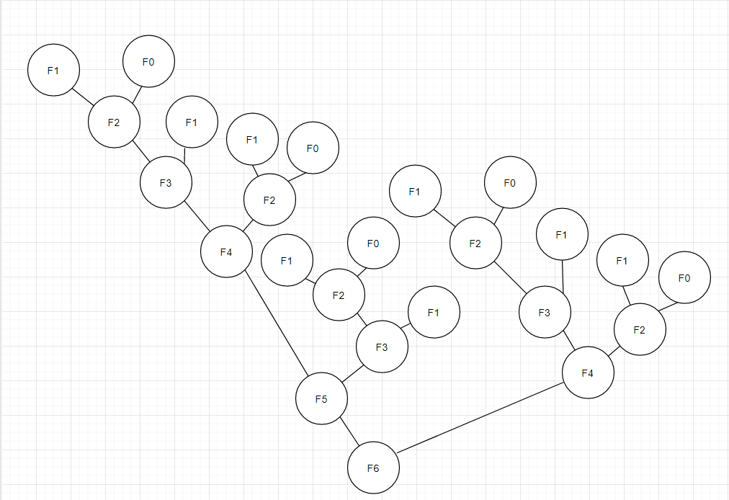a) Algorithm 1 does perform redundant calculations as it’s true only terminates at the base case.

b)

c) For F6 F5 is called once, F4 is called twice, F3 is called three times and F2 is called five times.

2.

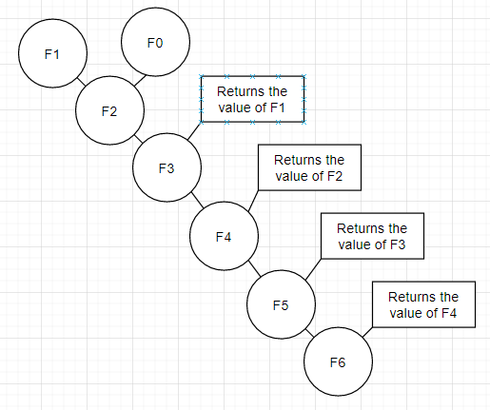a) Algorithm 2 doesn’t perform redundant calculations as it only calculates each branch once.

b)

c) For F6 F5 is called once, F4 is called once, F3 is called once and F2 is called once.

3. Algorithm 2 is more cost efficient as it only calls each branch once and avoids redundant calculations while Algorithm 1 repeats calculations already made.

4. It is O(6n). The six comes from needing to do a termination test, increment the variable for the loop, retrieving the two array elements, adding them and assigning it to the array.

5. It is O(5n). I ???

6. Algorithm 4 is more cost efficient as it doesn’t require the creation on an array and retriving the values and instead does all the work in the stack. \

7. It is log(n) probably.

8. I would use algorithm 5 for large n values and algorthim 4 for smaller ones. Algorthim 5 is more effeicent but has a larger start up time.